Appendix
In this appendix, you will find documents that should be presented at key points in the process of turning a church over from one senior pastor to another senior pastor.
1. Intent to Hire Document
2. Commission Document
3. Ordination Document
4. Sample Letter of Resignation
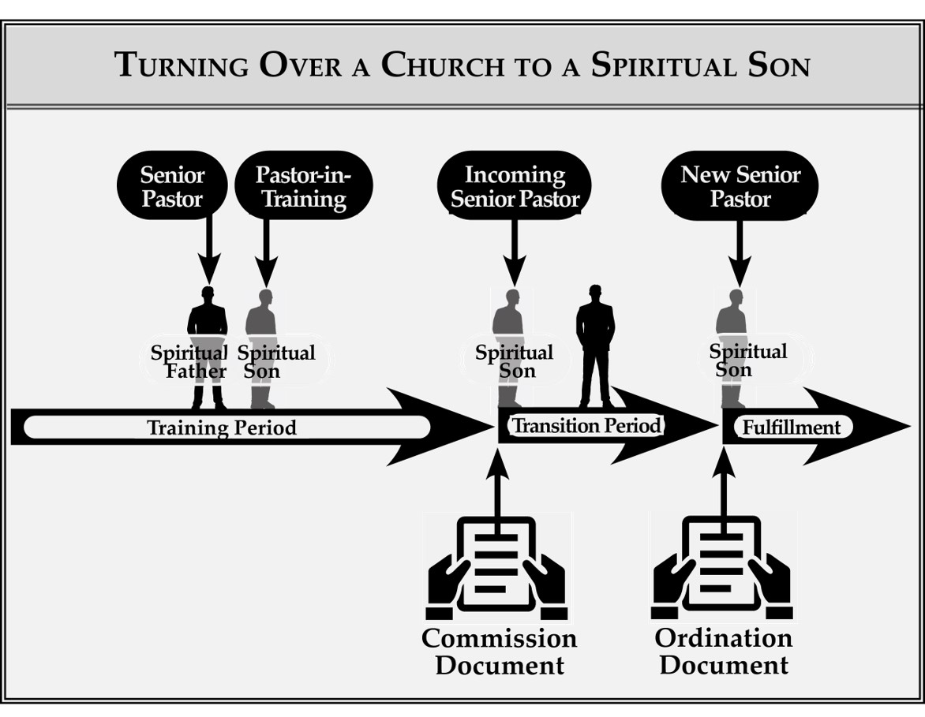
The timing as to when these documents are presented is revealed in the two diagrams that follow.

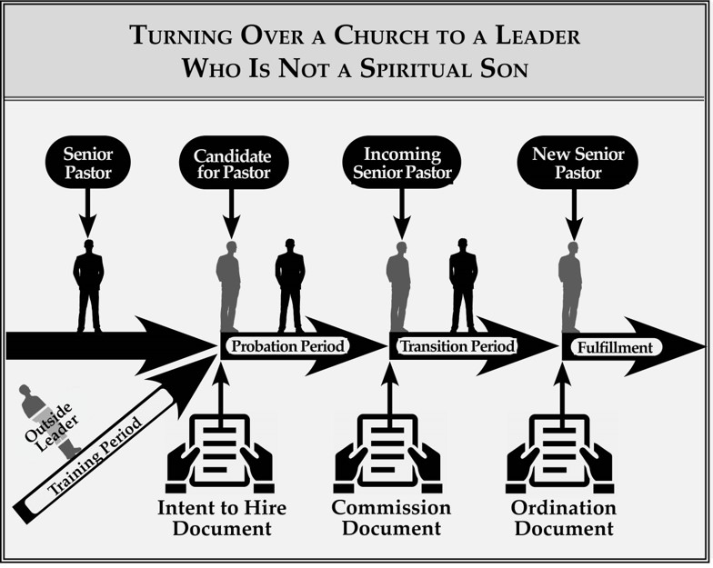
All staff members should give a letter of resignation to the senior pastor on the day he is first installed as the new senior pastor. All other leaders, i.e., elders and board members, who hold any official authority in the church, should give a letter of resignation to the new senior pastor within one year after the date he is first installed as the new senior pastor.
The documents provided in this appendix are examples. They may be used as written here, or church leaders may choose to make changes to adapt them to their own unique circumstances.

Intent to Hire Document

On this _______ day, of ________________________, in the year ____________, the senior pastor and leadership team of _____________________________ Church enter into an Intent to Hire agreement with ______________________________________, who is now recognized as the “candidate for the position of senior pastor.”
This intent to hire is no guarantee of future employment or of any position. Instead, it is a means of communicating clearly that both the senior pastor and leadership team are committed to hire the candidate for the senior pastor position if they find he is qualified for the position by the end of the probationary period.
The probationary period begins the day this document has been signed by all parties and then presented to the candidate for the position of senior pastor. The probationary period ends on the _______ day, of ________________________, in the year ____________.
At any time during this probationary period, either party (the senior pastor and leadership team or the candidate for the senior pastor position) may end the probationary period by giving to the other party a written two weeks’ notice. With that notice, no reason needs to be stated. At the completion of that two-week period, the probationary period will end, resulting in no further consideration of the candidate to be the senior pastor.
During the probationary period, the candidate will perform the following duties:
__________________________________________________________________________________________
__________________________________________________________________________________________
__________________________________________________________________________________________
__________________________________________________________________________________________
During the probationary period, the candidate will be compensated for his service as stated below:
__________________________________________________________________________________________
__________________________________________________________________________________________
__________________________________________________________________________________________
__________________________________________________________________________________________
During the probationary period, the candidate will be under the direct authority and supervision of the senior pastor, ________________________________.
By signing below, you agree to the statements and commitments written in this document.
SIGN PRINT DATE
SENIOR PASTOR
____________________________ ____________________________ ___________
LEADERSHIP TEAM
____________________________ ____________________________ ___________
____________________________ ____________________________ ___________
____________________________ ____________________________ ___________
____________________________ ____________________________ ___________
____________________________ ____________________________ ___________
____________________________ ____________________________ ___________

CANDIDATE FOR THE POSITION OF SENIOR PASTOR

_________________________ _________________________ _________

Commission Document

On this _______ day, of ________________________, in the year ____________, the senior pastor and leadership team of _____________________________ Church testify they have made an irrevocable decision to turn the position of senior pastor over to ______________________________________, at the end of a specified transition period.
The transition period begins on the day this document is presented to ______________________________________, who will be identified during the transition period as the “incoming senior pastor.” During the transition period, the current senior pastor will be identified as the “outgoing senior pastor.” This transition period will end on the _______ day, of ________________________, the year ____________, which will also be the day on which the incoming senior pastor will be fully installed as the senior pastor.
The transition period is for the purpose of the outgoing senior pastor to work himself out of his position and the incoming senior pastor to work into that position.
During the transition period, the incoming senior pastor will be under the authority of the outgoing senior pastor. However, the out-going senior pastor will turn authority over to the incoming senior pastor, in appropriate, agreed-upon ways, keeping in mind he is to work himself out of his position during the transition period and fully transfer all authority to the incoming senior pastor by the end of the transition period.
During the transition period, the incoming senior pastor will perform the following duties:
__________________________________________________________________________________________
__________________________________________________________________________________________
__________________________________________________________________________________________
__________________________________________________________________________________________
During the transition period, the incoming senior pastor will be compensated for his service as stated below:
__________________________________________________________________________________________
__________________________________________________________________________________________
__________________________________________________________________________________________
__________________________________________________________________________________________
Immediately upon the installation of the incoming senior pastor as the new senior pastor, the outgoing senior pastor will give up all authority as the senior pastor. After the incoming senior pastor is installed as the senior pastor, the outgoing senior pastor, ______________________________________, will be involved in the church in the following ways. (Describe what, if any, involvement the previous senior pastor will have.)
__________________________________________________________________________________________
__________________________________________________________________________________________
__________________________________________________________________________________________
__________________________________________________________________________________________
Once the incoming senior pastor is installed as senior pastor, he will have full authority over the outgoing senior pastor pertaining to any activity or relationships within the church.
By signing below, you agree to the statements and commitments written in this document.

Sign Print Date
SENIOR PASTOR
____________________________ ____________________________ ___________
LEADERSHIP TEAM
____________________________ ____________________________ ___________
____________________________ ____________________________ ___________
____________________________ ____________________________ ___________
____________________________ ____________________________ ___________
____________________________ ____________________________ ___________
___________________________ ____________________________ ___________
INCOMING SENIOR PASTOR

____________________________ ____________________________ ___________

Ordination Document

On this _______ day, of _______________________, in the year ____________, the senior pastor and leadership team of _____________________________ Church recognize ______________________________________ as the senior pastor of _____________________________ Church, carrying the title of senior pastor, and possessing all the authority associated with the position of senior pastor, including the authority to hire and fire any and all staff members.
The job description of the new senior pastor includes, but is not limited to:
__________________________________________________________________________________________
__________________________________________________________________________________________
__________________________________________________________________________________________
__________________________________________________________________________________________
The new senior pastor will be compensated as follows:
__________________________________________________________________________________________
__________________________________________________________________________________________
__________________________________________________________________________________________
__________________________________________________________________________________________
The senior pastor will seek unity among the elders and endeavor to make all major decisions only with the elders in full agreement. However, if consensus cannot be reached after sincere efforts have been made, the senior pastor will have the final authority in all matters except those mentioned below:
__________________________________________________________________________________________
__________________________________________________________________________________________
__________________________________________________________________________________________
__________________________________________________________________________________________
The elders, without the senior pastor, will determine by unanimous agreement any changes in compensation for the new senior pastor.

The elders, without the senior pastor, may remove the senior pastor by unanimous decision if he is found to be in serious sin, such as moral failure, purposeful financial mismanagement, or prolonged heretical teaching.
On the day, this document is presented to the new senior pastor, or as soon as possible thereafter, all staff members will submit letters of resignation to the new senior pastor. Within one year from the day this document is presented to the new senior pastor, all leaders (including elders and board members) carrying authority beyond staff positions will submit letters of resignation to the new senior pastor.
After the day this document is presented to the new senior pastor, the previous senior pastor, ______________________________________, will be involved in the church in the following ways. (Describe what, if any, involvement the previous senior pastor will have.)
__________________________________________________________________________________________
__________________________________________________________________________________________
__________________________________________________________________________________________
__________________________________________________________________________________________
Once the incoming senior pastor is installed as senior pastor, he will have full authority over the outgoing senior pastor pertaining to any activity or relationships within the church.
By signing below, you agree to the statements and commitments written in this document.

SIGN PRINT DATE
PREVIOUS SENIOR PASTOR
____________________________ ____________________________ ___________
LEADERSHIP TEAM
____________________________ ____________________________ ___________
____________________________ ____________________________ ___________
____________________________ ____________________________ ___________
____________________________ ____________________________ ___________
____________________________ ____________________________ ___________
____________________________ ____________________________ ___________
NEW SENIOR PASTOR
____________________________ ____________________________ ___________

Sample Letter of Resignation

January 15, 2020

Senior Pastor of Christian Living Church
871 Chambers Ave.
Hopeville, CA 12345

Dear Pastor John Smith,

Please accept this as my letter of resignation from my position as director of finances. Unless you contact me within the next two weeks, I will be out of my office by January 30, 2020.

If I can be of any assistance during this transition, please let me know.

I am grateful for the opportunity I have had to serve Christian Living Church.

Sincerely yours,

Jennifer Christian
(123) 456-7890

